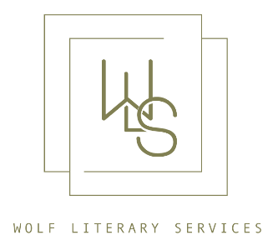

Wolf Literary Services

London 2024

Contact:

Rach Crawford (rachel@wolflit.com / rights@wolflit.com )

135 West 29th Street, Suite 603, New York, NY 10001| wolflit.com

FICTION

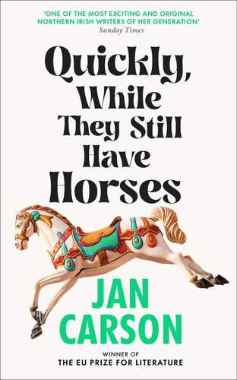
QUICKLY, WHILE THEY STILL HAVE HORSES
by Jan Carson

Publisher: Doubleday Ireland (UK/Comm) + Editor: Kirsty Doole
Pub date: July 2024 + Materials: Proofs.
Category: Short story collection + Agent: Kate Johnson.
Rights sold: N/America: Scribner.
+ From the EU Prize-winning author of
THE FIRE STARTERS
In sixteen sparkling stories, Jan Carson introduces us to worlds and characters that feel real enough to touch. All of life is here: the thrill of growing up, the grief when youth is over; first love, mature love, parenthood and loss - all shot through with profound compassion, warm wit, and boundless imagination.
Every so often, an irresistible suggestion of the other world will surprise and delight, reaffirming Carson as a thrillingly original and audacious talent, and making Quickly, While They Still Have Horses the perfect introduction for readers new to her work.
PRAISE FOR JAN CARSON:
“One of the most exciting and original Northern Irish Writers of her generation.”
THE SUNDAY TIMES
“An original and exciting work that's equal parts terrifying, hilarious and memorable... It is truly one of those books in which every piece fits together like the cogs of a watch.”
SUNDAY TIMES IRELAND
“Jan Carson is a writer of astounding empathy, giving every character - alive or dead - a voice that rings brilliantly true. A real gem.”
RUTH GILLIGAN
“This superb book deserves all the plaudits and praise going.”
SUNDAY INDEPENDENT, on The Raptures
“An Agatha Christie-esque whodunnit, a dark supernatural mystery and an account of mass trauma ... Compassionate and meticulously observed.” THE GUARDIAN on The Raptures
Jan Carson is a writer and community arts facilitator based in Belfast. Her first novel, Malcolm Orange Disappears, was published in 2014 to critical acclaim, followed by a short-story collection, Children's Children (2016), and two flash fiction anthologies, Postcard Stories (2017) and Postcard Stories 2 (2020). Her second novel, The Fire Starters (2019), won the EU Prize for Literature and was shortlisted for the Dalkey Novel of the Year Award and her third novel, The Raptures (2022) was shortlisted for the Irish Book Awards Novel of the Year and the Kerry Group Novel of the Year. Her work has appeared in numerous journals and on BBC Radio 3 and 4. She has won the Harper's Bazaar short-story competition and has been shortlisted for the BBC National Short Story Award, the An Post Irish Short Story of the Year, and the Seán Ó Faoláin Short Story Prize. She specializes in running arts projects and events with older people, especially those living with dementia.
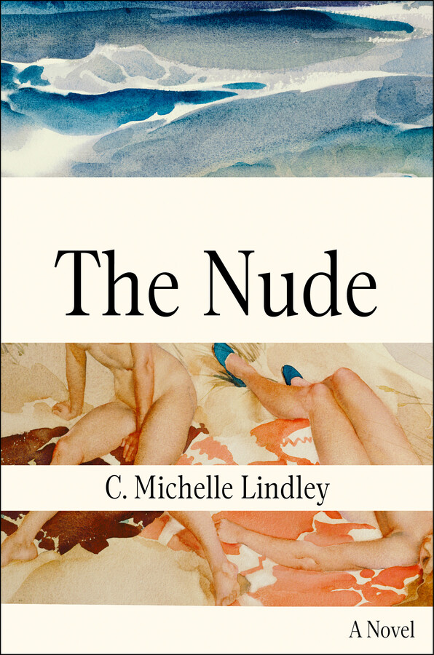
THE NUDE
by C. Michelle Lindley

Publisher: Atria (N/Am) + Editor: Jade Hui.
Pub date: June 2024 + Materials: Manuscript.
Category: Literary + Agent: Kate Johnson.
Rights sold: UK/Comm: Verve Books.
+ Debut novel, sold at auction.
A gripping, provocative, and sensual debut novel about an art historian who journeys to a Greek island in pursuit of a found sculpture and quickly finds herself immersed in a cultural tug-of-war and a complicated love affair.
1999: An island off the southern coast of Greece. Art historian Elizabeth Clarke arrives with the intent to acquire a rare female sculpture. But what begins as a quest for a highly valued cultural artifact evolves into a trip that will force Elizabeth to contend with her career, her ambition, and her troubling history.
Disoriented by jet lag, debilitating migraines, and a dependence on prescription pills, Elizabeth turns to her charming and guileless translator to guide her around the labyrinthine island. Soon, the island’s lushness—its heat and light, its textures and tastes—take hold of Elizabeth. And when she’s introduced to her translator’s inscrutable wife—a subversive artist whose work seeks to deconstruct the female form—she becomes unexpectedly enthralled by her. But once the nude’s acquisition proves to be riskier than Elizabeth could have ever imagined, Elizabeth’s and the statue’s fate are called into question. To find a way out, Elizabeth must grapple with her past, the role she’s played in the global art trade, and the ethical fallouts her decisions could leave behind.
The Nude is an evocative and intense exploration of art, cultural theft, and what it means to be a woman helming morally complicated negotiations in a male-directed world.
C. Michelle Lindley’s writing has been featured in The Georgia Review, Conjunctions, and more. She has received support from the National Endowment for the Arts and has an MFA in Creative Writing from Cornell University and a BA from the University of Berkeley in English and Art History. The Nude is her first novel.
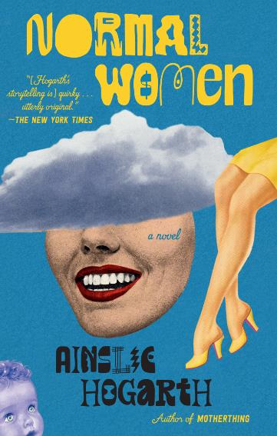
NORMAL WOMEN
by Ainslie Hogarth

Publisher: Vintage (N/Am) + Editor: Caitlin Landuyt.
Pub date: October 2023 + Materials: Final pdf.
Category: Literary/upmarket + Agent: Rach Crawford.
Rights sold: UK/Comm: Atlantic Books (ed. James Roxburgh); Canada: Strange Light.
+ From the author of cult favorite, Motherthing.
In this darkly comic story about how we value female labor—and don’t—a new mother becomes embroiled in danger when her friend, a controversial entrepreneur, goes missing.
When her daughter Lotte was born, Dani had welcomed the chance to be a stay-at-home mother. To be good at something, for once. But now Dani can’t stop thinking about her seemingly healthy husband, Clark, dropping dead. Not because she hates him (not right now, anyway) but because it’s become abundantly clear to Dani that if he dies, she and Lotte will be left destitute.
And then Dani discovers The Temple. Ostensibly a yoga center, The Temple and its guardian, Renata, are committed to helping people reach their full potential. And if that sometimes requires sex work, so be it. Finally, Dani has found something she could be good at, even great at; meaningful work that will protect her and Lotte from poverty, and provide true economic independence from Clark.
Just as Dani is preparing to embrace this opportunity, Renata disappears. And Dani discovers there might be something else she’s good at: uncovering secrets.
“Ainslie Hogarth is the master of first sentences, and the god of surprising verbs.”
CLAIRE OSHETSKY
“Like MOTHERTHING, Hogarth's second novel invites readers to share a gloriously subversive look at the contractual expectations inherent in human relationships: NORMAL WOMEN takes on sex work, performative motherhood, and the 'wellness' industry, with surprises lurking around every corner. It's also funny as fuck.”
ALLY WILKES
"An exhilarating ride of a novel that deliciously and irreverently skewers the complacent, the entitled and the self-satisfied."
CAROLE HAILEY
“creeping suspense, laugh-out-loud humor, and smart critiques of the ways gendered expectations wear on people’s self-worth, enjoyment of life, and relationships. . . . A conversation starter about gender roles and sex work”
KIRKUS REVIEWS
AINSLIE HOGARTH is the author of the novels Motherthing, The Lonely and The Boy Meets Girl Massacre (Annotated). She lives in Canada with her husband, kids, and little dog.

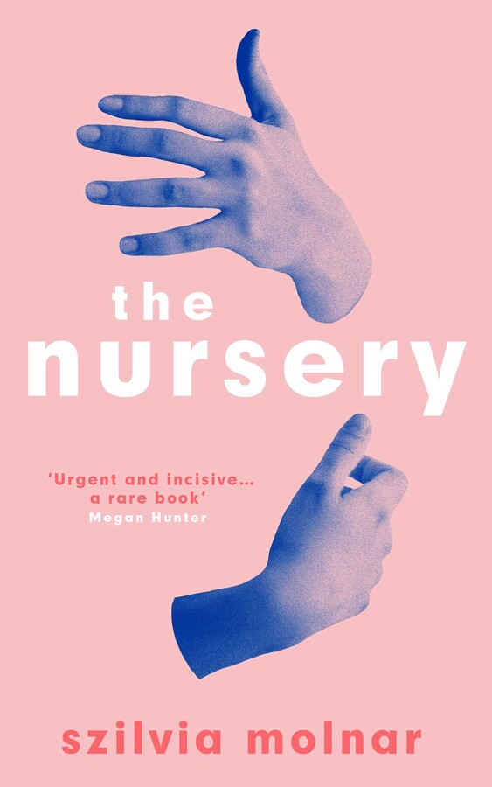
THE NURSERY
by Szilvia Molnar

Publisher: Pantheon (N/Am) + Editor: Lisa Lucas.
Pub date: Jan 2022 + Materials: Final pdf.
Category: Literary + Agent: Kate Johnson.
Rights sold: UK/Comm: Oneworld (ed. Juliet Mabey); French: Actes Sud; German: Aufbau; Portuguese (Brazil): Todavia; Hungarian: Open Books; Swedish: Bakhall; Italian: Guanda; Turkish: Ayrinti Yayinlari.
+ Sold in a pre-empt.
+ Buzzy debut for readers of Hanya Yanagihara and Rachel Cusk.
A remarkable debut novel about the early postpartum days of motherhood: a visceral and revelatory portrait of a woman struggling with maternal fear and its looming madness, showing how difficult and fragile those days can be, and how vital love is to pull anyone out from the dark.
“Brilliant…an essential and surprisingly thrilling book about motherhood”
THE NEW YORK TIMES
“A radical novel…I’m obsessed with this book.” JESSAMINE CHAN
“A powerful brew of a novel… Molnar has written a daring and much-needed novel that has some of the hothouse, unflinching quality of Sylvia Plath’s late poetry." THE ATLANTIC
“Fans of Nightbitch by Rachel Yoder should look forward to The Nursery. It is a searing portrait of postpartum motherhood. Molnar’s visceral writing is to die for.” DEBUTIFUL
"The Nursery dares to question the inviolable dictates of a mother’s love when a human is reduced to her suffering" BOMB MAGAZINE (Editor's Choice)
"Molnar’s entrancing debut captures the volatile inner life of a woman with postpartum depression...a powerful look at what a new mother endures." PUBLISHER’S WEEKLY
"An essential, singular contribution to the literature of mothering as a human, embodied, fundamentally existential experience." MERRIT TIERCE
"The Nursery dares to put a woman's body at the center of the story, a book as frightening as it is profound, as gory as it's beautiful, a reeling vision of postpartum experience unlike any." LOUISA HALL
“A concise, powerful novel on bringing art and life into the world, by a beautiful prose stylist. Molnar's precision and phenomenal ear for language gives us new words for the oldest experience.” LYDIA KIESLING
Szilvia Molnar is the foreign rights director at a New York-based literary agency, and author of a chapbook called Soft Split. Her work has appeared in Guernica, Lit Hub, Triangle House Review, Two Serious Ladies, The Buenos Aires Review, and Neue Rundschau. Szilvia is from Budapest and was raised in Sweden. She lives in Austin, Texas.
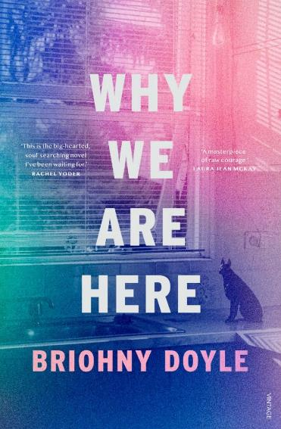
WHY WE ARE HERE
by Briohny Doyle

Publisher: Vintage Australia (ANZ) + Editor: Meredith Curnow.
Pub date: June 2023 + Materials: Final pdf.
Category: Literary + Agent: Rach Crawford.
+ From a Miles Franklin Longlisted author.
+ Author is rising star of Australian writing.
After her partner and father die in quick succession, BB moves to a glamorous, condemned beachside apartment at the edge of a city so memory-saturated it might be a mirage. Her plan? To rediscover the person she was before finding, and losing, the love of her life.
But then a neighbor mistakes her for a dog trainer, and enlists her in correcting the murderous tendencies of his Doberman. Harnessing the tenets of Cesar Millan the dog whisperer, and other less canine-centric canons, she helps local dogs and their wealthy, oblivious owners to distinguish between the things they can and cannot change. Why We Are Here is a singular story for strange days, for fans of Sheila Heti and Sigrid Nunez.
“Existential, moving and hilarious. A heartfelt exploration of grief and renewal told through the cinematic and surrealist prose of an author at the top of her game.” THE AUSTRALIAN
“Brilliant and tender, Why We Are Here is a riveting study in grief, waywardness, and renewal. By turns raw, funny, intellectual, and searching. This is the big-hearted, soul-searching novel I’ve been waiting for.” RACHEL YODER
“This astonishing novel sets new bearings for Australian fiction in the 2020s. Doyle is on fire.” REBECCA GIGGS
“A masterpiece of raw courage – shot through with the humour, heart and more-than-human understanding that is central to Doyle's work.” LAURA JEAN MCKAY
“Why We Are Here is a book of capacious wisdom filled with deep insights and luminous prose.” BOOKSELLER + PUBLISHER
“moving and intellectually engaging” ABC RADIO NATIONAL
“Why We Are Here is a lot more fun than you might expect. BB’s observations are wry and often exceptionally funny … a wildly relatable account of deep mid-life reflection.” MEANJIN
Briohny Doyle is the author of Echolalia, Adult Fantasy and The Island Will Sink. Her books have been recognized on lists for The Miles Franklin Literary Award, the Victorian Premier’s Literary Awards and The Melbourne Prize for Literature. Her writing has appeared in The Monthly, The Guardian, Meanjin, The Griffith Review, and The Age. She is a lecturer in creative writing at The University of Sydney, and a former Fulbright scholar.
Highlighted backlist: Echolalia (2021) longlisted for the Miles Franklin Award, Shortlisted for the Victorian Premier’s Prize for Fiction. Called “a significant Australian novel” by ABC RADIO.

Non-Fiction

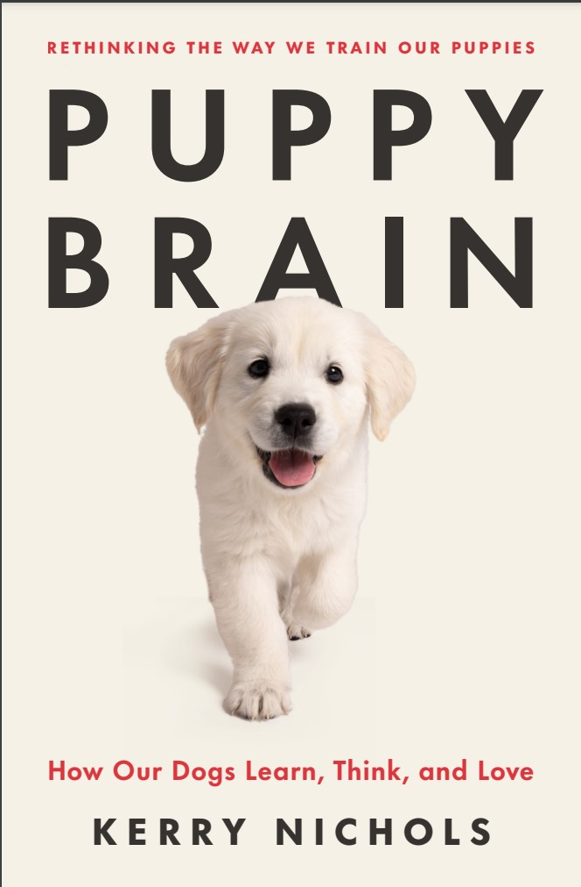
PUPPY BRAIN:
How Our Dogs Learn, Think, and Love
by Kerry Nichols

Publisher: Celadon/Macmillan (N/Am) + Editor: Randi Kramer.
Pub date: April 2024 + Materials: Proof pages.
Category: Practical / science + Agent: Leigh Eisenman.
+ Sold at auction.
+Author has 230,000+ instagram followers
How do you raise a happy, healthy, and emotionally resilient dog? Full of actionable guidance, Puppy Brain will show you how to create a harmonious, fulfilling relationship with your pet.
Kerry Nichols, professional dog breeder and expert, brings readers front and center for a puppy’s developmental journey.
Through years of research into brain development and the use of intentional rearing protocols, Kerry has developed an approach that results in a harmonious, fulfilling relationship with our dogs rather than one steeped in rote obedience.
With guidance about everything from crate training to spaying and neutering, Puppy Brain distills the latest insights and breakthroughs from canine research into practical, actionable, evidence-based guidance.
The perfect book for dog lovers and psychology enthusiasts alike, Puppy Brain is the definitive resource for anyone looking to raise their puppy with respect and love.
“The first twelve months is the most important time frame in a puppy’s life, when it comes to setting the stage for your dog’s long term mental, emotional and behavior wellbeing. This book shows you how to prepare for a successful first year, building a rock-solid foundation that will last a lifetime.” —Karen Shaw Becker, Wellness Veterinarian and co-author of #1 New York Times bestseller The Forever Dog
"Nichols combines an understanding of behavioral and developmental science with practical experience into a philosophy and method of establishing a strong, functional bond with your canine companion. She has a wonderful talent for explaining the seemingly unexplainable aspects of the human/animal bond." —Bruce W. Christensen, Veterinarian and Specialist in Canine Reproduction, Founder Kokopelli Veterinary Center
Kerry Nichols is a former attorney turned canine educator and advocate whose journey into the world of dogs began nearly fifteen years ago. With the founding of Nicholberry Goldens, she devoted herself to raising the healthiest Golden Retrievers possible. This evolved into a mission to instill emotional resilience and agency in her own puppies, a pursuit she now shares with an audience of hundreds of thousands of followers across social media. Her methods continue to garner support from leading veterinarians, trainers, and psychologists, and notable owners of her Goldens include executives from Facebook, Microsoft, and Tinder.
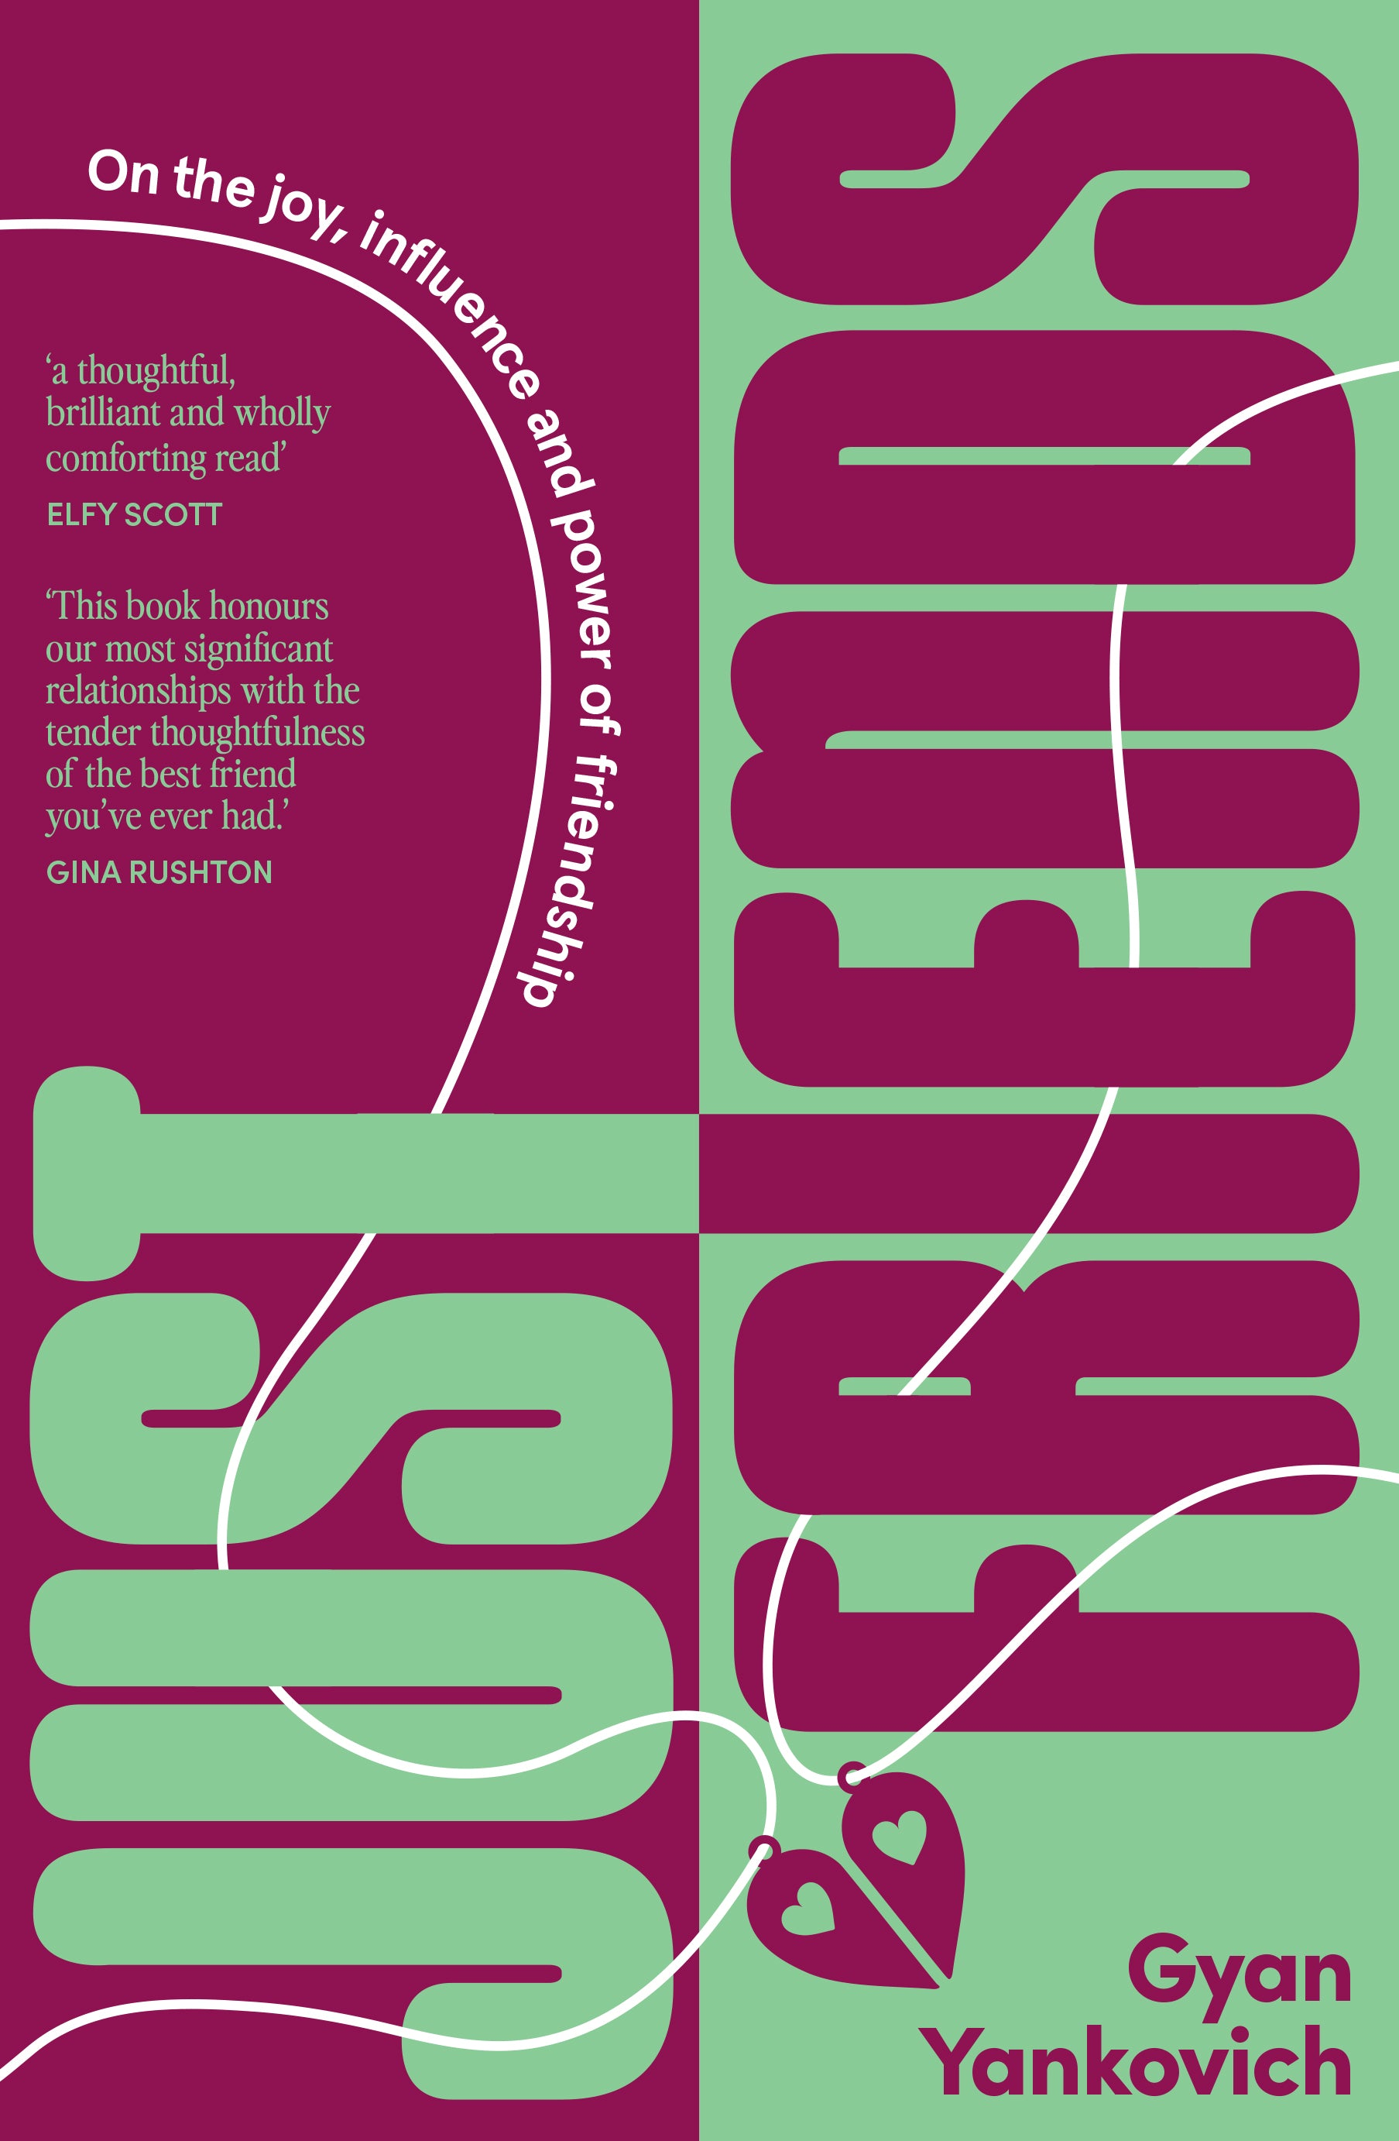
JUST FRIENDS:
On the Joy, Influence, and Power of Friendship
by Gyan Yankovich

Publisher: Ultimo Press (UK/Comm) + Editor: Brigid Mullane.
Pub date: February 2024 + Materials: First pages.
Category: Narrative nonfiction/lifestyle + Agent: Rach Crawford.
Rights sold: N/American: The Experiment.
+Instant Amazon bestseller, #1 across categories.
Voice memos, care packages, hours-long phone conversations, treasured traditions that go back decades, glasses held aloft during wedding toasts, hands held at funerals, first cuddles with newborns, work lunches with work wives, taking it to the group chat – our friendships touch and enrich every part of our lives. But how often do we stop to consider them deeply?
Just Friends explores modern friendship – what it means to be, to make and, sometimes, to lose a friend. It is a celebration of friendship, shining a light on the many different forms they can take and the comfort they provide, whether they exist within the workplace, emerge in motherhood, are uncovered inside our neighbourhoods, or become our chosen family.
Just Friends is an ode to the people that shape us. It is a book to devour on the beach or with a book club, a book to return to again and again, and, most importantly, a book to press into the hands of the friends you love the most.
‘a joyful, hopeful and considered book that will have you texting your friends in a hurry to tell them how much you appreciate them’ – Lucinda Price, author of Perfect Candidate
‘This book not only made me think about my friends in a different way, it also made me think about the kind of person I want to be.’ – Bridie Jabour, author of Trivial Grievances
‘a thoughtful, brilliant, and wholly comforting read’ – Elfy Scott, author of The One Thing We’ve Never Spoken About
‘This book honours our most significant relationships with the tender thoughtfulness of the best friend you’ve ever had.’ – Gina Rushton, author of The Parenthood Dilemma
Gyan Yankovich is a writer and editor based in Sydney, Australia. She is the lifestyle editor at the Sydney Morning Herald and The Age. She was previously based in New York, where she held editor roles at Man Repeller and BuzzFeed. Her work has been published in The Cut, Vox, The Guardian, VICE, and more, exploring lifestyle, culture, and relationships. Just Friends is her debut book.
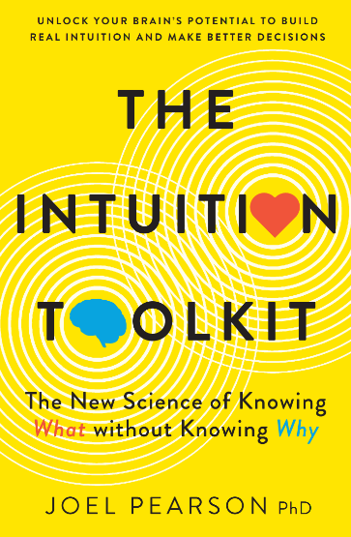
THE INTUITION TOOLKIT:
The New Science of Knowing What, Without Knowing Why
by Joel Pearson, PhD

Publisher: Simon & Schuster (ANZ) + Editor: Dan Rufino.
Pub date: February 2024 + Materials: Copyedited ms.
Category: Popular science/big think. + Agent: Rach Crawford.
Rights sold: UK/Comm ex. ANZ: Welbeck; Korean: RH Korea; China: China Translation and Publishing House; Spanish: Vaso Roto.
Five easy rules for developing intuition, based on trailblazing research by a neuroscientist. Intuition has saved lives and averted disasters, and it also lies behind countless innovative decisions. Steve Jobs, for one, regularly relied on his intuition in making business decisions at Apple.
Some people use intuition more readily than others but anyone can learn to develop and trust it. The key is ensuring that certain conditions are met so as to avoid the pitfalls. Neuroscientist Joel Pearson has identified five essential rules for using intuition, easily remembered by the acronym SMILE:
S: Self-awareness (Feeling emotional? Don't trust your intuition)
M: Mastery (Learn before you leap: why mastery matters for intuition)
I: Impulses and Addiction (These are not intuition)
L: Low Probability (Don’t use intuition for probabilistic judgments)
E: Environment (Use intuition only in familiar and predictable contexts)
In explaining these rules, Joel takes anecdotes from real life, including mountain climber Jon Muir’s lifesaving decision; a gameshow that uses humans’ innate misunderstanding of probability to rig its prizes; why you should never go rock-climbing on a first date; and what happens when Usain Bolt races in low gravity. The Intuition Toolkit is scientifically solid, highly readable and utterly fascinating.
“By demystifying intuition while providing a practical guide for safer decision-making, Pearson helps businesspeople, parents, high-risk professionals, or anyone willing to trust their gut to make better choices by using information stored in the unconscious. The Intuition Toolkit will appeal to fans of Malcolm Gladwell and those who were fascinated by the movie Inception" – Books+Publishing
Joel Pearson is a psychologist as well as a neuroscientist, and is the Director of Future Minds Lab at the University of New South Wales. He is also Head of Innovation & Enterprise in the School of Psychology at the same institution. He initially studied art and filmmaking at the College of Fine Arts, UNSW, before turning to the scientific mysteries of human consciousness and the complexities of the brain. He is a prolific public speaker and writer, having contributed chapters to several books and published numerous journal articles. Joel’s website is profjoelpearson.com.
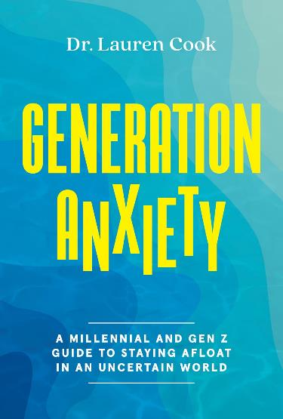
GENERATION ANXIETY:
A Millennial and Gen Z Guide to Staying Afloat in an Uncertain World
by Lauren Cook

Publisher: Abrams (N/Am) + Editor: Soyolmaa Lkhagvadorj.
Pub date: September 2023 + Materials: Finished copies.
Category: Self-help/psychology + Agent: Leigh Eisenman.
Rights sold: UK/Comm: Watkins (ed. Lucy Carroll); Portuguese (Brazil): Rocco; Thai: B2S; Romanian: Bookzone SRL; Spanish: Planeta Zenith.
+ 240k followers and 1.7m likes on TikTok.
+Author is a licensed clinical psychologist.
Millennials and Gen Z-ers are considered two of the most anxious generations in history, and with many intense generation-specific stressors facing them in recent years—including climate change, political polarization, systemic racism, gun violence, and financial instability—it’s easy to see why people are being diagnosed with anxiety at alarming rates.
Dr. Lauren Cook, a licensed clinical psychologist who specializes in treating Millennials and Gen Z clients, and a Millennial who also lives with anxiety, understands the many nuanced reasons why these two groups are struggling in different ways than their predecessors. Taking a feminist and intersectional lens, Dr. Cook shares her own struggles with anxiety and provides easy, actionable steps to help readers ride the waves of anxiety rather than constantly swimming against them. This relatable, honest, and information-packed book incorporates thorough, evidence-backed psychological research and diverse client experiences to illustrate a broad range of presentations of anxiety to help readers gain insight into their own stressors and combat anxiety.
"Dr. Lauren is my absolute go-to when it comes to working through anxiety. Generation Anxiety is a must-read for anyone who experiences anxiety or wants to support someone who does. Given that so many of us are feeling overwhelmed by everything going on in the world, this book not only belongs on your shelf, it belongs in your mind!" JESS EKSTROM
Dr. Lauren Cook is a licensed clinical psychologist, speaker, and career coach. She began her training at UCLA, where she majored in psychology and communication studies. She earned her master’s degree in marriage and family therapy from the University of Southern California, then completed her doctorate in clinical psychology at Pepperdine University. Dr. Cook created the Name Your Story mental health group training curriculum that has been utilized by thousands of collegians around the country. She has been featured in the New York Times, the Chicago Tribune, Forbes, PBS, Shape, Bustle, and many other digital and print publications. She is represented for speaking by CAMPUSPEAK and has given more than 500 talks at various companies, universities, and organizations. She lives in Pasadena, California.

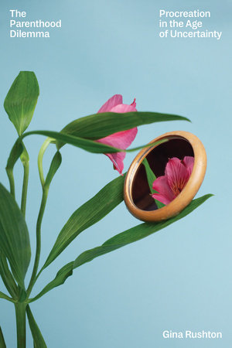
THE PARENTHOOD DILEMMA:
Procreation in the Age of Uncertainty
by Gina Rushton

Publisher: Astra House (N/Am) + Editor: Alessandra Bastagli.
Pub date: September 2023 + Materials: Finished copies.
Category: Narrative nonfiction + Agent: Rach Crawford.
Rights sold: UK/Comm: Indigo Press (ed. Susie Nicklin); ANZ: Pan Macmillan; China: Beijing BBT.
Should we become parents? When journalist Gina Rushton, afflicted with endometriosis, admitted she had little time left to make this decision, the magnitude of the choice overwhelmed her. Her search for her own “yes” or “no” only uncovered more questions to be answered. How do we clearly consider creating a new life on a planet facing catastrophic climate change? How do we reassess the gender roles we have been assigned at birth and by society? How do we balance ascending careers with declining fertility? How do we know if we’ve found the right co-parent, or if we want to go it alone, or if we don’t want to do it at all?
To seek clarity on these questions, Rushton spoke to doctors, sociologists, economists, and ethicists, as well as parents and childless people of all ages and from around the world. Here, she explores and presents policies, data, and case studies from people who have made this decision—one way or the other—and shows how the process can be revelatory in discovering who we are as individuals.
“This is an honest, compelling, well-researched book that makes a valuable contribution to the contemporary discussion about reproductive choices and rights in a nuanced and thoughtful way.” —Dr Pragya Agarwal, author of (M)OTHERHOOD and HYSTERICAL
"I loved the beautifully written introspection and the meticulous reporting around considerations like climate change, fertility, genes, and reproductive rights - even as Rushton comes to understand that ‘no one is going to write the ending for me.’ I hate the term ‘must-read,’ but damn it, everyone considering having kids in this chaotic era should read this book." —Amber Sparks, author of And I Do Not Forgive You
"With a journalist’s doggedness, a philosopher’s scope, and a thirtysomething woman’s sense of a deadline looming, Gina Rushton rips back the sentimental gauze of motherhood to confront a question as urgent as it is unmentionable: Should I - should anyone - bring a child into a world on fire? For parents and non-parents alike, this book is a call to arms to build a fairer, freer, more sustainable, and more truly feminist future." -- Joanna Scutts, author of Hotbed: Bohemian Greenwich Village and the Secret Club that Sparked Modern Feminism
Gina Rushton is a multi-awarded reproductive rights and women’s health reporter and editor whose work has been published in BuzzFeed News, The Guardian, Vogue, Associated Press, The Sydney Morning Herald, and The Monthly. This is her first book.

Co-Agents

China, Taiwan, Thailand, Vietnam, Malaysia: The Grayhawk Agency

Croatia, Slovakia, Slovenia, Bosnia, Macedonia, Montenegro: Corto Literary Agency

France: Agence Eliane Benisti

Germany: Thomas Schlueck GmbH

Greece: Read n’ Right Agency

Israel: The Deborah Harris Agency

Italy: Berla & Griffini Rights Agency

Japan: The English Agency

Korea: Duran Kim Agency

Poland, Czech Republic, Bulgaria, Serbia, Romania, Estonia, Latvia, Lithuania, Moldova, Albania, Ukraine: Graal Literary Agency

Spain, Brazil, Latin America, Portugal: The Foreign Office

